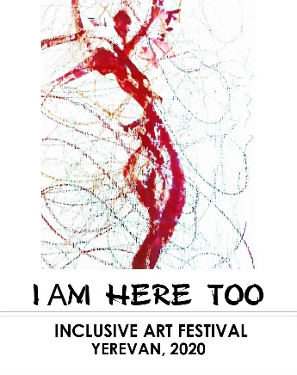
Annex №2
Attention! The information mentioned in the application will be used for granting the prizes to the participants, in documents related to the Festival, and for contacting the contestants.
The organizers of the Festival are not responsible for any mistakes in the information provided.

Festival Application Form

1. Group name (Provide full name and address of the organization) ______________________________________________________________________________ ______________________________________________________________________________
______________________________________________________________________________
2. Full name of the group leader _______________________________________________________________________________
3. The number of group members
______________________________________________________________________________
4. The art direction _______________________________________________________________________________
5. The title of the performance and the duration
_______________________________________________________________________________
6․Author of the performance
_______________________________________________________________________________
7․ Any technical requirements for the performance _______________________________________________________________________________
_______________________________________________________________________________
_______________________________________________________________________________
7. Contact person name, address, phone number, email address

8. Web link (Youtube) _________________________________________________________________________

- Participants’ information
№ | Surname, last name, passport details | Date of Birth | Selected working group | Special requirements, if any

